Steps to Accessing External eLearning (ulearn)

- Select the link to access the site - ulearn.ottawa.ca (http://ulearn.ottawa.ca/)

*** In order to avoid any formatting/layout discrepancies when accessing this site, please ensure that you use the exact same link as indicated above.

- If necessary, you can change your language by selecting the drop down in the upper left hand corner of the page

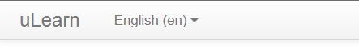

- Select the Log in button in the upper right hand corner of the page

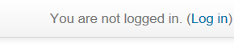

- You will see the log in screen for training.

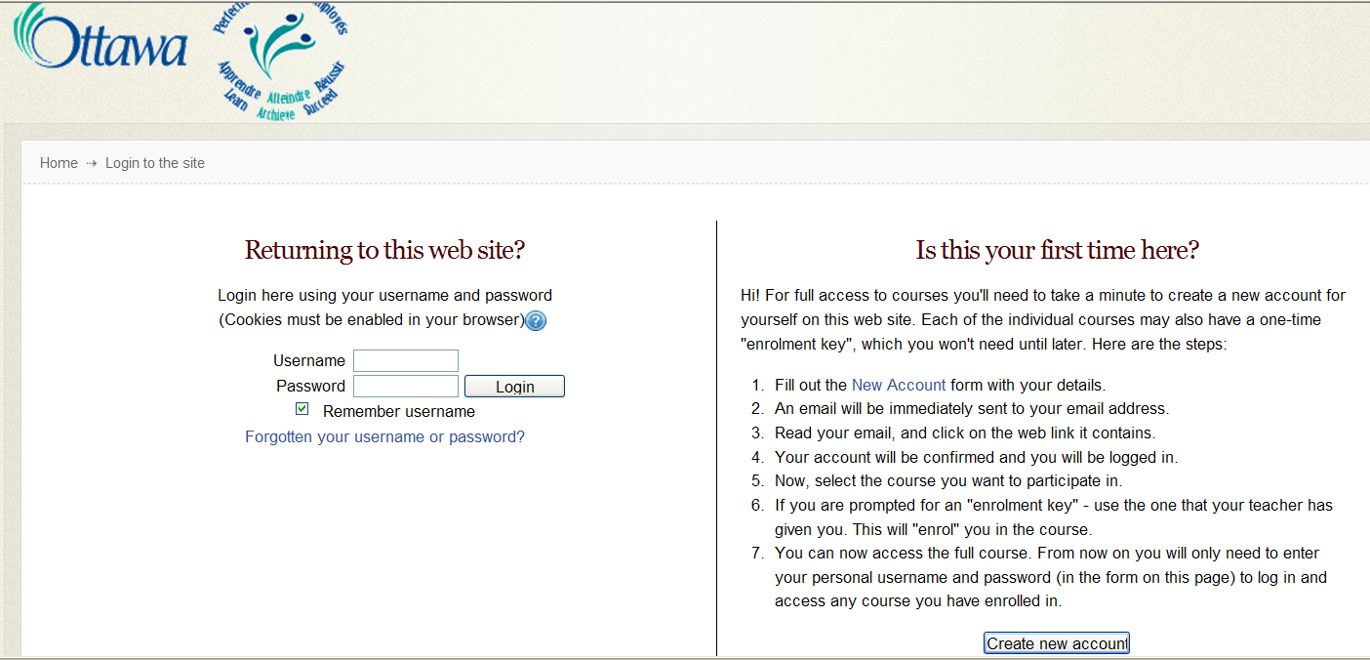
- For those who have never been on the system before- Select “ Create New Account” on the right side of the screen. Fill in the required fields (the name you use must be exactly the same as the name that you have on your City documentation forms)

- *** Remember to write down your username and password and keep them confidential. This will allow you to re-enter the system should you not complete all modules at one time.

- Once this information is completed, a link will immediately be sent to you by email. Look in your junk mail for Web Admin User [noreply@ulearn.ottawa.ca] if it does not appear in your inbox.
*** In order to confirm your registration, you must open the email from “Web Admin User” and select the link contained in the email message.
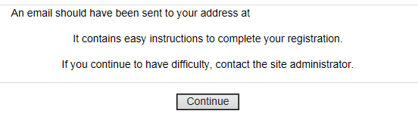
address xxxxx.xxx
- Open the email and select the link to confirm your registration.
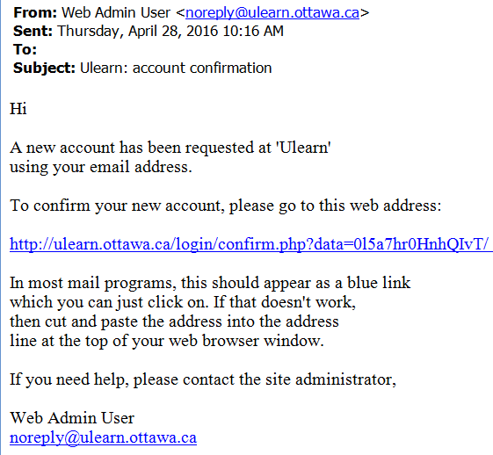

- You will be prompted with a message confirming your registration.

- Select the Courses button to view the course listing.

Thanks, xxxxxxxx (your name)
Your registration has been confirmed.

Courses

- You will see a Departmental listing of available courses. Select “Ottawa Public Health”.
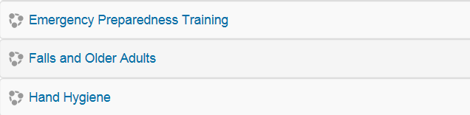
- From the course list, select Falls and Older Adults.

- A prompt is displayed indicting that you are about to enrol yourself in this course. Select “Enrol Me” to confirm your enrolment.

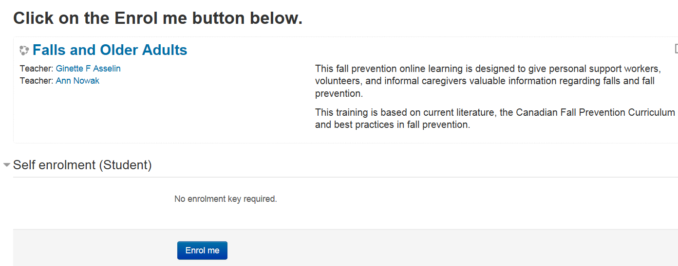

- Follow the instructions on the main course page to enter and complete the modules as required.

Note: To re-enter the system at a later date to complete your training, please enter your Username and password on the left side of the screen under “Returning to this web site”.
***If you have forgotten your Username or password select the “Forgotten your username or password?” link directly below “Returning to this web site”.

